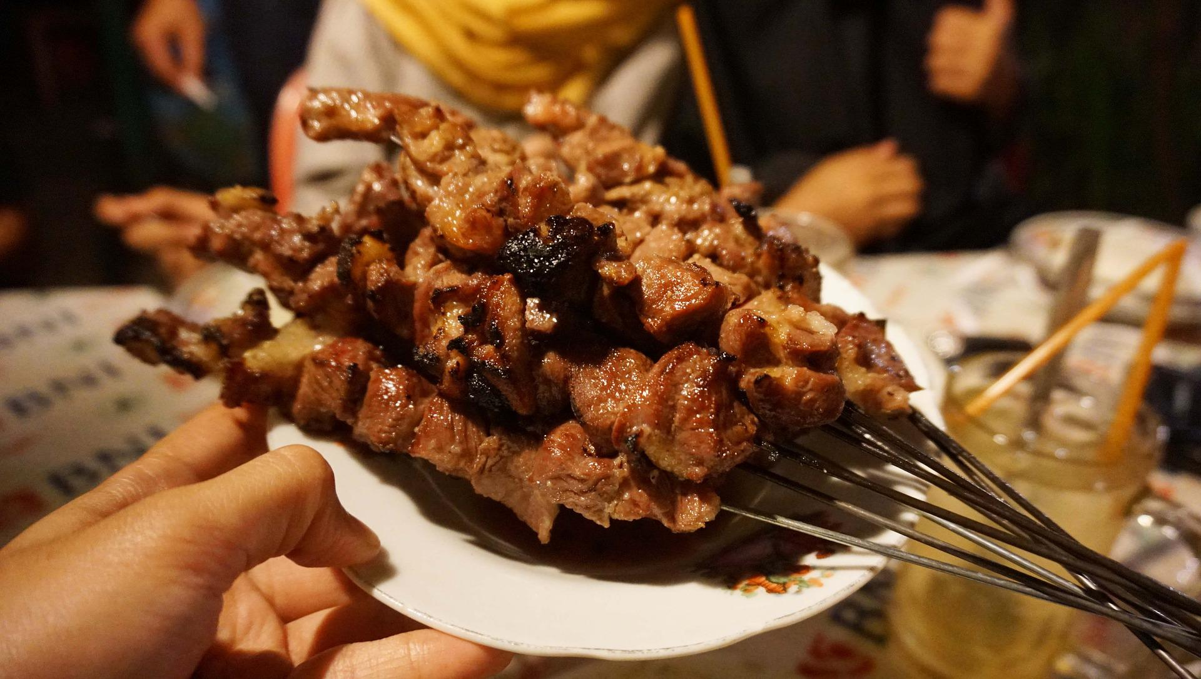

Business Plan Template for a BBQ Restaurant by Wise Business Plans

[Company Logo]

[Company Name]

[Company Address]
[Company Phone Number]

Developed By:

[Name]
[Your Role]
[Company Name]
[Address]
Email: [ ]
Document Version

Business Plan Confidentiality Agreement
The undersigned reader of [Company's Name] Business Plan acknowledges that the information provided is totally confidential, and undertakes not to reveal anything discovered in the business plan without the express written agreement of [Business Owner's Name].
The reader also acknowledges that the information to be provided in this business plan is confidential in all aspects, with the exception of information that is in the public domain through other means, and that any disclosure or use of the same by the reader may cause serious harm and or damage to [Company Name].

This business plan document will be returned to [Business Owner's Name] immediately upon request.
This is a business plan. This document does not make or intend to make any offer.

Table of Contents

1. Executive Summary……………………………………………………………………….##
2. Company Overview..……………..……………….…….…….…….…...……………….##
3. Industry Analysis………………………………....…………………….….…….………..##
4. Customer Analysis…………………………………………….…...….….…….………...##
5. Competitor Analysis…………...………………………………………………………….##
6. Marketing Plan…………………....……………………………….…….…….…….…….##
7. Operations Plan………….....……………………………………………………………..##
8. Management Team………….....…………………………………………………………##
9. Financial Plan…………….….….………………………………………………………….##
10. Appendix……………………………….…………………………………………………##

Executive Summary

Provide a one-two-page overview of your BBQ business and highlight the most important details. A typical executive summary includes:

- Business Overview

Describe what your BBQ offer, its goals, and objectives?

- Products and Services

List your BBQ products in more detail, if applicable. Describe the products you offer.

- Customer Focus
Provide a concise and clear definition of your BBQ target market, as well as the need you hope to fulfill.

- Financial Highlights

How much capital, if any, are you seeking for your BBQ business, and how you are going to use them?
- Management Team

Outlines your management team, staff, resources, and how your BBQ business is structured.

Company Overview
This section summarizes your BBQ business. You should include the company's registered name, physical address, key people, the company's history, its nature, and your company's goals. Let's break down these sections
Company Profile
- What is your location?
- When did you form?
- What is the legal entity form of your company?
Company Mission/Vision Statement
- What are the objectives of your company?
Previous Accomplishments

- Describe the past accomplishments that have your BBQ business already achieved

Industry Analysis
BBQ industry overview

- Briefly describe the BBQ industry. Define the BBQ industry in terms of its history, geographical service area, and products.
BBQ industry trends
- Examine trends and growth patterns in the BBQ industry.
Relevant Market Size
- How large is your relevant market (the number of customers who can realistically buy from you)?
Factors affecting the BBQ industry
- Determine what factors influence the BBQ industry. These may include government regulations and other businesses' competitive practices.
Five Years Forecast
- What will your BBQ company's position be in the industry in five years? Identify opportunities that your company can take advantage of in the industry.

Customer Analysis

Identify your target customers
- Who are your target customers? Please provide a detailed demographic profile.

Factual information obtained is categorized as follows:
- Demographic data: Age, gender, income
- Geographic: Location, type of area (Rural, suburban, urban)
- Psychographic: Values, interests, beliefs, personality, lifestyle
- Behavioral: Behavior patterns, frequent actions, buying habits
Customer Needs
- What are the key needs of your target audience?

How do your BBQ products align with customer needs?
- Explain how your BBQ products benefit the customer and what its Unique Selling Proposition is. Describe how your offerings make your customers' lives easier.

Competitive Analysis

Describe the state of competition in your BBQ industry. You may want to include a SWOT analysis here or in your appendix.
List your top competitors along with the following details for each:

Direct Competitors
- What are your direct competitors? Which are their strengths and weaknesses?
Indirect Competitors,
- Who are your indirect competitors? Which are their strengths and weaknesses?
Competitive Advantage
- What makes you different from your competitors? Do you have sustainable advantages (can your competitors emulate you)

Competitor Name | Strength(s) | Weakness(es) | Competitive Advantage
Competitor A
Competitor B
Competitor C

Marketing Plan
Brand positioning
Why are potential buyers going to be interested in your BBQ products? How will you address your buyer persona’s biggest challenges and goals?
Example: The [Company Name] brand will emphasize the Company's unique value proposition:

- Providing organic, high-quality food.
- Providing a convenient location with both eat-in and take-out options.
- Providing outstanding customer service.
Pricing Strategy
What is the maximum amount you can charge? And how do you maximize your income by balancing sales volume and price?
Placing
The location of your BBQ business is referred to as place. Document your location and explain how it will affect your success.
Is your BBQ establishment, for example, next to a densely populated society or in the mall? Discuss how your location could provide a consistent flow of customers.
Promotion
How will you market your BBQ products? Are you going to market your BBQ products at a price that matches the quality? Will it be a low-cost, no-frills alternative to similar offerings available from other BBQ businesses? Describe your advertising strategy. When will you advertise?

Operations Plan

The following are two parts to your operations plan.
Key Operational Processes
- What are the key operational processes your BBQ company must perform on a daily basis to succeed?

Goal | Plan | Action | Responsibility | Deadline

Business Milestones
- Over the next 1-3 years, what milestones will you need to achieve success?

Date | Milestone
Date 1
Date 2
Date 3 | `
Date 4

Management Team
Your management team section of the BBQ business plan should contain the following key elements:
Organizational Structure:
- Highlights the hierarchy and outlines responsibilities and decision-making authority.
Management Team Members
- Highlights the company's management team. Also, providing details of key employees, such as their qualifications, experience, or skills can add a competitive edge to the image of the business.
Working Structure:
- Describes how your management team will operate within your BBQ business structure.
Expertise:
- Provides details about your team's business expertise.
Management Team Gaps
- Who else needs to be hired?
Skills Gap:
- Explain what your BBQ company is planning to do to improve staff skills and expertise. In this section, you should address your plans for acquiring new information and knowledge.

Financial Plan

Revenue Model
- How does your BBQ business generate revenue?
Sales Forecast
- The sales forecast is exactly what it sounds like: your projections, or forecast, of what you think you will sell in a given period.
Financial Highlights
- How do you project your topline financials over the next five years?
Funding Requirements/Use of Funds
- How much money will you need to start and/or run your BBQ business? How will you use these funds?

Appendix
A business plan's appendix is the place where you can include any additional documents that you want to use to give your readers a feel for your services, marketing, services, etc.
Some examples:
- Startup Costs sheet
- 5 Year Annual Income Statement
- 5 Year Annual Balance Sheet
- 5 Year Annual Cash Flow Statement

