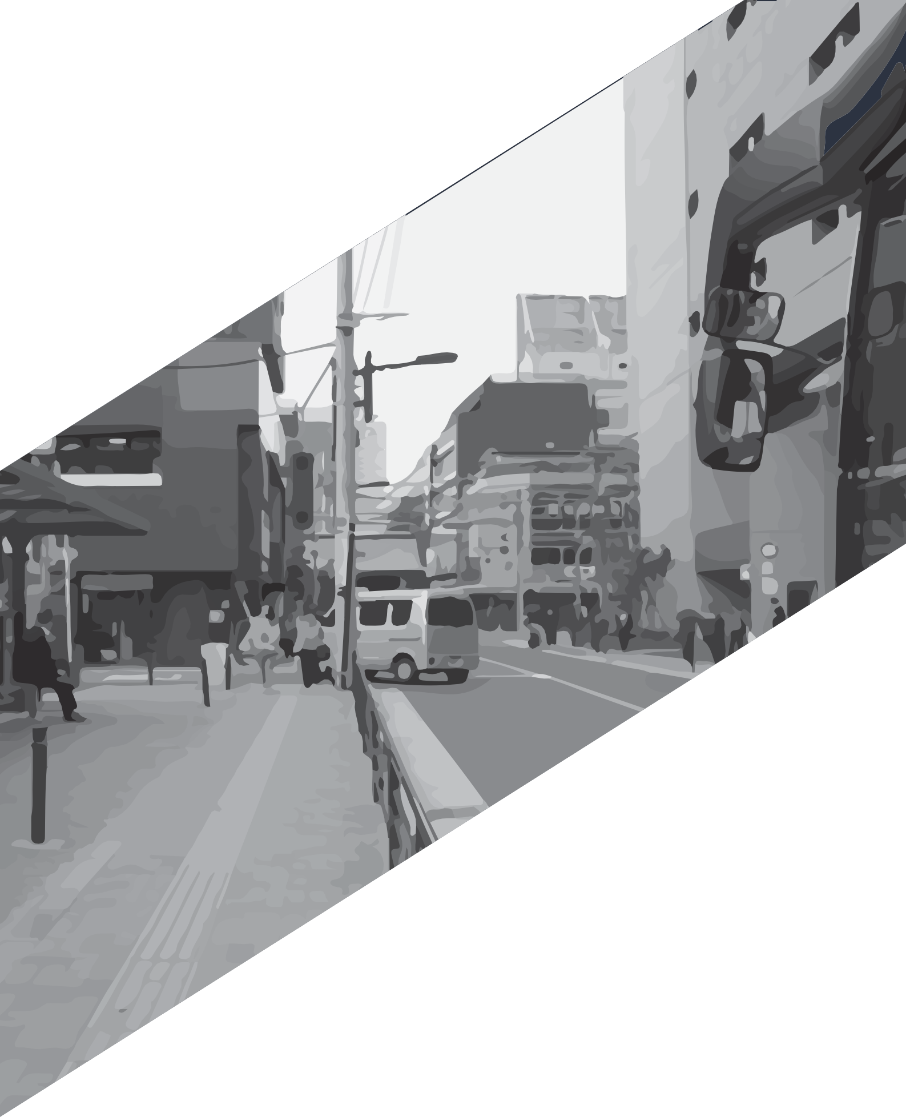L

Wise Business Plans
Clothing Line Business Plan

JUNE 2022
BUSINESS PLAN

Joseph Ferriolo

+1 800-496-1056

info@wisebusinessplans.com

7251 W Lake Mead Blvd #300, Las Vegas, NV 89128, United States Wisebusinessplans.com

It is understood that the information provided in this [Company’s Name] Business Plan is totally confidential, and the reader undertakes not to disclose any aspect of it without the express written consent of the business owner.

